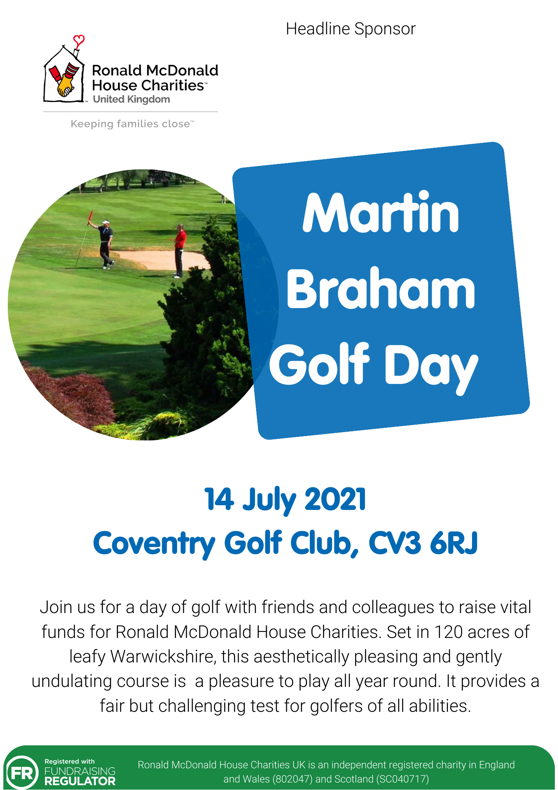

Places are limited, therefore to secure your booking please complete this registration form and return to charlotte.smith@uk.mcd.com We hope that you will be able to attend this event and / or support with sponsorship, auction or raffle prizes.

Registration Form
Contact Name: | Click here to enter text.
Company Name: | Click here to enter text.
Address: | Click here to enter text.
Post Code: | Click here to enter text.
Telephone Number: | Click here to enter text.
Email Address: | Click here to enter text.
How did you hear about the golf day?
☐ I’m happy for Ronald McDonald House Charities to email me with news about the Charity, stories about families my donations help, future events and campaigns. For more information about how we use your data, please read our Privacy Policy: www.rmhc.org.uk/privacy-policy

Team Entry and Sponsorship
Corporate Team Entry:  Includes one hole sponsorship  Early bird special £700 if booked and paid before 14 April, after £750 | £750  Early bird £700 | ☐ Yes ☐ No
Standard Team Entry:  Early bird special £500 if booked and paid before 14 April, after £550 | £550  Early bird £500 | ☐ Yes ☐ No
Team Name and details  Please submit names and handicaps by 30 June | Name | Handicap
Player 1:
Player 2:
Player 3:
Player 4:
Hole Sponsorship | £150 | ☐ Yes ☐ No
Food Sponsorship | £300 | ☐ Yes ☐ No
Competitions Sponsorship | £300 | ☐ Yes ☐ No
Halfway House Sponsorship | £450 | ☐ Yes ☐ No
Goody Bags Sponsorship | £500 | ☐ Yes ☐ No
Yellow Ball Competition (Team Entry) | £20 | ☐ Yes ☐ No
All Four on the Green (Team Entry) | £20 | ☐ Yes ☐ No
Beat the Pro (Team Entry) | £20 | ☐ Yes ☐ No
Team Mulligans (2 per player) | £40 | ☐ Yes ☐ No
Additional Diners | £45 | ☐ Yes ☐ No
Total: | £0,000.00
Please let us know if you are able to donate any of the following and if yes, provide a description:
Donation of Raffle Prize | Click here to enter text.
Donation of Auction Item | Click here to enter text.

Please note that we currently do not have buggies available for the day.

All cheques should be made payable to ‘MGB Restaurants Ltd’ and sent to the address below. BACS details will be included on your invoice. Detailed information for the day will be sent to the primary contact, closer to the date. Evening dress code is smart casual.
Address: R Gardner, MGB Restaurants Ltd T/A McDonald’s Restaurants Ltd, 109 Coventry Road, Small Heath, Birmingham, B10 0RJ

All cancellation requests should be made in writing either by email or post subject to the following conditions; A full refund will be granted up to 60 days prior to the event; Cancellations made within 60 days of the event will incur 50% of the total price of the booking; •Cancellations made within 14 days of the event will incur 100% of the total price of the booking. Our event is COVID secure and your team booking will be guaranteed against any date changes.

